**Retrieve ALL products**

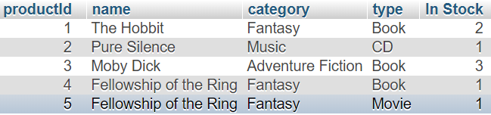

SELECT

p.`productId`,

p.`name`,

p.`category`,

p.`type`,

COUNT(p.`productId`) AS "In Stock"

FROM

`Product` AS p

INNER JOIN `Stock` AS s

ON

p.`productId` = s.`productId`

GROUP BY

p.`productId`

**Retrieve Products that are available**

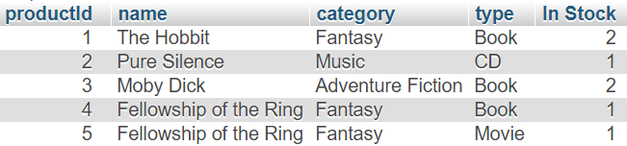

SELECT

p.`productId`,

p.`name`,

p.`category`,

p.`type`,

COUNT(p.`productId`) AS "In Stock"

FROM

`Product` AS p

INNER JOIN `Stock` AS s

ON

p.`productId` = s.`productId`

WHERE NOT EXISTS

(

SELECT

*

FROM

`ItemRental` AS r

WHERE

r.`stockId` = s.`stockId` AND(

`status` = "Rented" OR `status` = "WaitingShipment" OR `status` = "WaitingReturn"

)

)

GROUP BY

p.`productId`

**Retrieve Products Waiting to Ship**



SELECT

p.`productId`,

p.`name`,

p.`category`,

p.`type`,

s.`stockId`

FROM

`Product` AS p

INNER JOIN `Stock` AS s

ON

p.`productId` = s.`productId`

WHERE EXISTS

(

SELECT

*

FROM

`ItemRental` AS r

WHERE

r.`stockId` = s.`stockId` AND `status` = "WaitingShipment"

)

**Retrieve Products Waiting to be Returned**

SELECT

p.`productId`,

p.`name`,

p.`category`,

p.`type`,

s.`stockId`

FROM

`Product` AS p

INNER JOIN `Stock` AS s

ON

p.`productId` = s.`productId`

WHERE EXISTS

(

SELECT

*

FROM

`ItemRental` AS r

WHERE

r.`stockId` = s.`stockId` AND `status` = "WaitingReturn"

)

**Search Products by name, type**

name =”fellowship of the ring” AND type=”book”



name=”fellowship of the ring” AND type=”movie”



SELECT

*

FROM

`Product`

WHERE

`name` LIKE CONCAT('%', nameSearch, '%') AND `type` = typeSearch

**Check rental count of member**



SELECT

COUNT(r.`memberId`) AS "Current Rentals",

m.`name`

FROM

`ItemRental` AS r,

`Member` AS m

WHERE

r.`memberId` = m.`memberId` AND `status` <> "Returned" AND r.`memberId`="selectedMemberId"

GROUP BY

m.`name`

**Creating ItemRental when member orders**

INSERT INTO `ItemRental`(`stockId`, `memberId`, `status`)

VALUES(

selectedStockId,

selectedMemberId,

"WaitingShipment"

)

**Updating ItemRental when employee ships**

UPDATE

`ItemRental`

SET

`status` = "Rented"

WHERE

`itemRentalId` = selectedRentalId AND `status` = "WaitingShipment"

**Updating ItemRental when member returns item**

UPDATE

`ItemRental`

SET

`status` = "WaitingReturn"

WHERE

`itemRentalId` = selectedRentalId AND `status` = "Rented"

**Updating ItemRental when employee processes return**

UPDATE

`ItemRental`

SET

`status` = "Returned"

WHERE

`itemRentalId` = selectedRentalId AND `status` = "WaitingReturn"

**Retrieve a Member’s Address**

SELECT

`address`

FROM

`Member`

WHERE

`memberId` = selectedMemberId